The role of TORC1 in muscle development in Drosophila.

Isabelle Hatfield1, Innocence Harvey1, Lawrence T. Reiter2,3and Dave Bridges1,2,*

1Department of Physiology; 2Department of Pediatrics; 3Department of Neurology, University of Tennessee Health Science Center, Memphis, TN 38163

*Corresponding Author:

Address: Department of Physiology, 894 Union Ave, Memphis, Tennessee, 38163

Email: [dbridge9@uthsc.edu](mailto:dbridge9@uthsc.edu)

# Abstract

Myogenesis is an important process during both development and muscle repair. Previous studies suggest that mTORC1 plays a role in the formation of mature muscle from immature muscle precursor cells. Here we show that gene expression for several myogenic transcription factors including *Myf5*, *Myog* and *Mef2c* but not *MyoD* decreases when C2C12 cells are treated with rapamycin, implying a role for mTORC1 pathway during muscle development. To investigate the possibility that mTORC1 can regulate muscle *in vivo* we ablated the essential mTORC1 subunit Raptor in *Drosophila melanogaster* and found that muscle-specific ablation of *Raptor* causes flies to be too weak to emerge from their pupal cases during eclosion. Furthermore, we found that there is a critical period post-eclosure when *Raptor* ablation causes lethality in flies. Together these results highlight an important new role for mTORC1 in late muscle development, integrity or function.

# Background

The mTOR signaling pathway plays important roles during development in all eukaryotes and mTORC1 is a critical nutrient sensing protein kinase conserved in all eukaryotic organisms1,2. This kinase responds to nutrient and growth hormone signals in the environment and subsequently phosphorylates targets involved in aging, growth, protein lipid and glycogen metabolism3–5. In addition to these effects on differentiated cells, there is an emerging role for mTORC1 in the regulation of cellular differentiation during development including neurogenesis6,7, adipogenesis8 and myogenesis9–11. Consistent with these findings, either loss of the obligate mTORC1 complex members mTOR and Raptor, or treatment with rapamycin induces developmental arrest in mice12–14, worms15 and fruit flies16.

Myogenesis occurs both during development and throughout life via the differentiation of muscle precursor cells called satellite cells17–19. This process involves a cascade of transcription factors including several basic helix-loop-helix transcription factors such as *Myf5, Myog, Myod* and *Mef2c* (reviewed in20,21). The direct target of mTORC1 on myogenesis has not been clearly established, but recent work has implicated mTORC1 in the regulation of MyoD protein stability, leading to a *miR*-1 dependent effect on myotube fusion22.

**Table 1:** Forward and reverse primers used in qPCR experiments. All primers are based on mouse sequences.

|  |  |  |
| --- | --- | --- |
| Gene | Forward Sequence | Reverse Sequence |
| *Cdkn1a* | GGAACATCTCAGGGCCGAAA | CTGACCCACAGCAGAAGAGG |
| *Mef2c* | ACGGGGACTATGGGGAGAAA | AATCTCACAGTCGCACAGCA |
| *Myf5* | CCACCTCCAACTGCTCTGAC | AGCTGGACACGGAGCTTTTA |
| *Myod1* | TCCTCATAGCACAGGGGTGA | GCAAGCTGTGGGGAAAAGTG |
| *Myog* | CAGCCCAGCGAGGGAATTTA | AGAAGCTCCTGAGTTTGCCC |
| *Gapdh* | CACTTGAAGGGTGGAGCCAA | ACCCATCACAAACATGGGGG |

To determine the relevance of mTORC1 on muscle differentiation *in vivo* we have examined the effects of loss of TORC1 by both genetic and pharmacological approaches in the fruit fly, *Drosophila melanogaster*. In this study we present data supporting an essential developmental role of TORC1 in late muscle development and/or stability.

# Materials and Methods

## Tissue Culture and Myotube Formation

C2C12 cells were grown in High Glucose Dulbecco’s Modified Eagle’s Medium (DMEM; Sigma-Aldrich) supplemented with penicillin, streptomycin and glutamine (PSG; Life Technologies) and 10% Fetal Bovine Serum (Sigma-Aldrich). Once cells reached >90% confluence, differentiation media (2% Horse Serum from Sigma-Aldrich in DMEM with PSG) was added as previously described23 To determine when specific markers for differentiation were being expressed, cell lysates were prepared at time points between 0 and 15 days of differentiation. To determine the effects of rapamycin on differentiation, cells were treated every other day for 9 days with either vehicle alone (DMSO; Sigma-Aldrich), or 500nM rapamycin (Cayman chemicals) dissolved in DMSO. Cell lysates were prepared on day 9 of treatment. Cell lysates were generated by washing once with ice-cold PBS followed by the addition of 1 ml of QIAzol (Qiagen) and scraping into a 1.5ml microfuge tube. Lysates were stored at -80°C until RNA was purified.

## Quantitative Real Time PCR

RNA was extracted with the PureLink RNA mini kit (Life Technologies). 1 g of total RNA was used as a template to synthesize cDNA using the High Capacity Reverse Transcription Kit (Life Technologies). cDNA was added to *Power* SYBR Green PCR Master Mix in accordance with the manufacturer’s guidelines (Life Technologies) and qRT-PCR performed on a Roche Lightcycler. A series of control genes including *Gapdh, Rplp0, Actb* and *Rplp13a* were examined, and *Gapdh* was chosen as a control as it did not change across rapamycin concentrations or differentiation conditions. For a complete list of primers and probes used, refer to Table 1. Relative expression was determined via the Ct method as previously described24.

## Drosophila Stocks and Crosses

The stocks *w1118*, the three muscle GAL4 drivers (*24B*-GAL4, *c179*-GAL4 and *mef2*-GAL4), as well as both the *Raptor* and *Tsc1* UAS-shRNA TRiP lines used (See Table 2) were obtained from the Bloomington Stocks Center (Bloomington, IN). All flies were raised at 25°C on standard corn meal food with the exception of the 18°C crosses for *24B*-GAL4. Rapamycin was added where indicated after fly food was cooled to below ~50° C**.** To prepare the crosses, virgin females were collected from each of the GAL4 driver strains. Ten virgin females were used per cross. Males with the appropriate genotype were chosen from each of the lines and crossed to male UAS-TRiP-shRNA lines for *Raptor* (3) or *Tsc1* (3) as well as a UAS-TRiP control which contains the genomic insertion site but no shRNA25. Flies were maintained in a humidified (50-60%) incubator at 25°C. A subset of experiments were also performed at 18°C. Ten days after each cross the F1 progeny began to eclose and adults were sorted according to phenotype and gender. During each sorting, the number of flies of each phenotype was recorded. The sorted flies were put into new vials, with males and females separated and with 5-10 flies in each vial. Progeny were stored at 25°C until at least 100 flies of each genotype had been collected. At least three independent replicates of each cross were performed.

## Quantification of Dead Pupae

Twenty days after the *c179-*GAL4>UAS-shRNA-*Raptor* and *Mef2-*GAL4>UAS-shRNA-*Raptor* crosses were made any remaining adult or F1 progeny flies were emptied from the vials. The empty pupal cases were counted and the cases containing dead flies were counted. Pupal cases containing a dead fly were markedly darker in color than the empty cases and contained a visibly formed black, shrunken fly.

**Table 2:** Fly stocks from Bloomington Stock Center used in this study.

|  |  |
| --- | --- |
| Name | Bloomington Stock # |
| *Raptor* shRNA #1 | 31528 |
| *Raptor* shRNA #2 | 31529 |
| *Raptor* shRNA #3 | 34814 |
| *Raptor* shRNA #4 | 41912 |
| *Tsc1* shRNA #1 | 31039 |
| *Tsc1* shRNA #2 | 31314 |
| *Tsc1* shRNA #3 | 35144 |
| Control shRNA Line | 36304 |
| *Hand-*GAL4 | 48396 |
| *24B-*GAL4 | 1767 |
| *C179-*GAL4 | 6450 |
| *Mef2-*GAL4 | 27390 |

## Manual Assistance of Eclosure

In order to determine if flies were dying because they were too weak to eclose from their pupal cases or dead in their pupal cases for other reasons we manually removed the anterior puparial operculum under a dissecting microscope using fine forceps from stage ~12-13 pupae that were fully formed, but had not yet eclosed. This was accomplished by using a thin sheet of plastic on the inside of the vial on which the 3rd instar larvae could form pupae. The sheet was then removed for imaging at various time points and to manually open the pupal cases then placed back into a fresh vial for incubation at 25 °C. Using this method allowed for the rescue of 3 mef2-GAL4>UAS-Raptor-shRNA adults that were too weak to begin to eclose, but with assistance of the removal of the operculum could get out of the case, inflate their wings and appeared morphologically normal.

## Climbing Assay

To perform the climbing assay flies were tapped to the bottom of a vial and a stopwatch was started simultaneously. The stopwatch was stopped each time a single fly from the group in the vial climbed to a mark at 4cm on the side of the vial. A separate time was recorded for each fly in the vial. This assay was performed within 3 days post eclosure and repeated every ~30 days for a total of 3 trials.

## Statistics

Statistical analyses were performed using the R statistical package (version 3.1.0)26. Prior to performing ANOVA analyses, normality was assessed by Shapiro-Wilk tests and equal variance was tested using Levene’s tests (from the car package (version 2.0-20)27). If both these assumptions were met (p>0.05) an ANOVA was performed. If either of these assumptions were not met, a Kruskal-Wallis test was performed. If either of those omnibus tests reached significance, then Student’s *t*-tests or Wicoxon Rank Sum Tests were performed as indicated, followed by an adjustment for multiple comparisons using the method of Benjamini and Hochberg28. Statistical significance for the manuscript was set at a *p* or *q*-value of < 0.05. The investigators were blinded to the genotype of the crosses until analysis. All raw data, analyzed data and code used to analyze the data and generate figures is available at <http://bridgeslab.github.io/DrosophilaMuscleFunction/>29

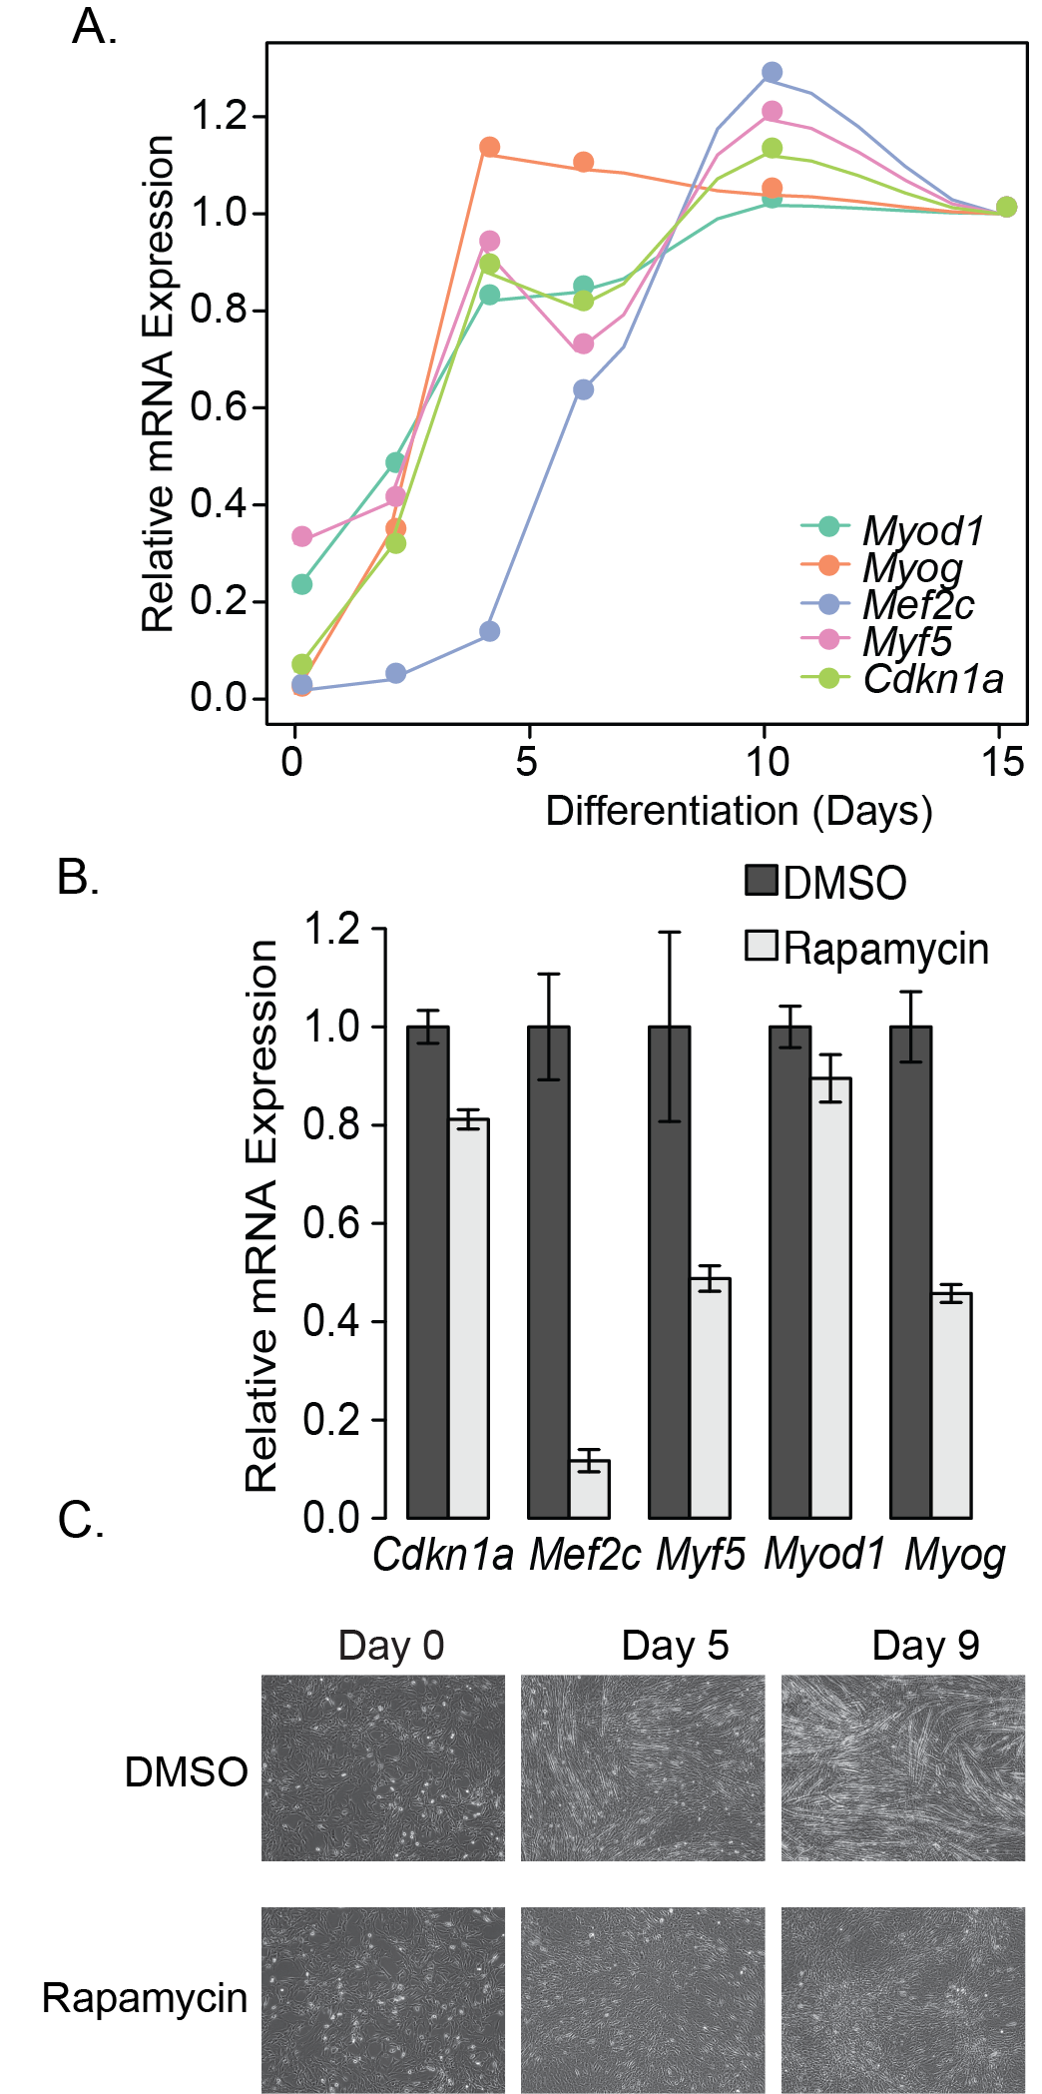

**Figure 1. Rapamycin blocks C2C12 differentiation.** A) The order of appearance of myotube differentiation markers over the course of 15 days in differentiation media only. This is representative of three independent experiments. B) Differences in differentation marker transcripts when treated with DMSO (vehicle) or 500nM rapamycin for 9 days. Transcripts from both A) and B) were measured by qRT-PCR and normalized to *Gapdh*. C) Images of morphological changes in C2C12 myoblasts in response to 9 days of DMSO or rapamycin treatment (500nM).

# Results and Discussion

## Rapamycin Inhibits Differentiation of Muscle Cells in Culture

To determine the order in which myogenic markers are induced during myogenesis, we performed a time course experiment in C2C12 cells. We generated cell lysates at various time points between 0 and 15 days of the differentiation process and performed qRT-PCR to measure transcripts of known differentiation markers including *Myf5*, *Myog*, *Mef2c*, *Cdkn1a*, and *Myod1*. We observed that transcripts for *Myf5*, *Myog*, *Cdkn1a*, and *Myod1* are increased early in the process (~ day 2) and continue to increase throughout development with large increases in *Mef2c* not occurring until approximately day 5 or 6 (Figure 1A). This is consistent with previous observations of the transcriptional changes associated with muscle differentiation of cells in culture30.

Next we wanted to determine if rapamycin, a drug known to inhibit TORC1 signaling, had any effects on gene expression during differentiation (Figure 1B and C). Treatment with rapamycin caused significant reductions in mRNA transcript levels detected for all differentiation markers measured (p<0.05), with the exception of *Myod1* (Figure 1B) and prevented the formation of myotubes (Figure 1C).

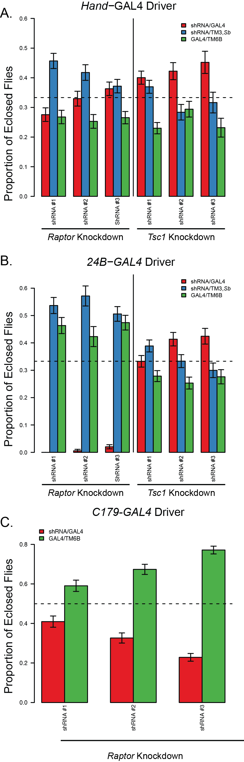

**Figure 2. Skeletal muscle specific Raptor knockdown causes lethality.** A) Proportion of progeny born from a *Hand*-GAL4/TM3, Sb x shRNAi/TM6B, *Tb, Hu*. The progeny that are TM6B/TM3 were excluded due to known reduced viability of flies with balancer chromosomes so the expected ratios (as indicated by the dotted line) are 0.33. Knockdown flies are shown in red throughout. B) Proportion of progeny born from a *24B*-GAL4/TM3, *Sb* x shRNA/TM6B, *Tb, Hu* cross. C) Proportion of progeny born from a *c179*-GAL4/*c179*-GAL4 x shRNAi/TM6B, *Tb, Hu* cross. In this case half the progeny should be knockdown, so the expected ratio is 0.5. Error bars indicate sampling standard error, with >195 flies examined for each cross.

Since rapamycin does not reduce the differentiation-associated elevation of *Myod1* transcript levels, consistent with previous findings22, it is unlikely that the mTORC1 target is upstream of *Myod1* transcription. Furthermore, since the elevation of several early differentiation targets, including *Myog*, *Myf5*, and *Cdkn1a* are all blocked by rapamycin our data supports the hypothesis that mTORC1 is required downstream of *Myod1* transcription but still quite early in the differentiation process*.* Since *Mef2c* does not increase until late in the differentiation process, and is downstream of *Myog*, reductions in *Mef2c* levels are likely due to defects upstream of *Myog*31. We therefore predicted that mTORC1, required for MyoD stabilization, may play a critical role in muscle development and should be tested in a live organism undergoing myogenesis.

These data show that the mTORC1 pathway is required to be active at a very early time point during the differentiation in C2C12 cells into myotubes. Additionally, these data indicate that *Myog*, *Myf5*, *Cdkn1a* and *Mef2c* all require mTORC1 function for their transcriptional activation during myogenesis. These data are consistent with the hypothesis that one role of mTORC1 in differentiation is through the stabilization of MyoD as previously suggested22, though whether there are other mTORC1 targets in early differentiation is not clear. Since the primary effect of miRNA-1 is on myotube fusion, it is likely that there are other mTORC1 dependent effects, as the morphological changes prior to myotube fusion are also disrupted by rapamycin11.

## Muscle Specific Knockdown of *Raptor* Leads to Late Pupal Lethality in Drosophila

In order to study the role of TORC1 signaling on muscle development *in vivo*, we manipulated dTORC1 function in the model organism *Drosophila melanogaster* (fruit flies). First, we tested whether inhibition of the dTORC1 pathway affected the development of these flies. As previously reported, high doses of rapamycin prevents egg laying in females16. We performed dose curves and found that at much lower doses (EC50 of ~860 nM), although eggs could be seen in the vials, there was a complete absence of pupae and adult flies (Supplementary Figure 1). At these lower doses, there was no obvious distinction between inhibition of pupal lethality and prevention of fly eclosure, ie there was no observable dose in which pupae survived but flies were unable eclose. These data suggest that rapamycin inhibits fly muscle development, similar to what has been observed in mice12. It also supports studies showing that whole animal knockout of *Raptor* leads to developmental lethality in several model organisms13–15,32.

To look specifically at the role of dTORC1 in muscle, we knocked down either *Tsc1* or *Raptor* to generate constitutive gain and loss of function of mTORC1 activity in fly muscles using the GAL4-UAS system33. We used several GAL4drivers that drove expression of the UAS shRNA cassettes in both skeletal muscle and cardiac muscle. We targeted skeletal muscle using *24B-*GAL4*, C179-*GAL4*,* and *Mef2-*GAL4 drivers, while cardiac muscle was targeted using the heart specific *Hand-*GAL4 driver. To minimize potential off target effects, three different shRNAs were used from the Harvard shRNA TRiP collection for each of the two genes (*Raptor* and *Tsc1*).

First, we crossed heterozygous, balanced *24B*-GAL4/TM3, *Sb* flies with heterozygous, balanced UAS-shRNA/TM6B transgenic flies. The flies inheriting both balancer chromosomes had decreased viability and were excluded from the analysis. Progeny from crosses using the *Hand-*GAL4 driver appeared in roughly equal ratios (Figure 2A), indicating there is no obvious effect of manipulating dTORC1 in cardiac cells. Similarly, *24B-*GAL4 driven expression of *Tsc1* shRNA had no significant effect on viability. However, when the *24B*-GAL4 driver was used to express *Raptor* shRNA, there was a dramatic decrease in the number of eclosed flies (Figure 2B). This indicates that *24B-*GAL4 driven expression of *Raptor* shRNA is lethal at some point prior to eclosure. Similarly, another muscle specific driver, *c179-*GAL4 crossed to heterozygous UAS-*Raptor*-shRNA/TM6B resulted in a reduced number muscle-specific *Raptor* knockdown flies (i.e. *c179*-GAL4>UAS-*Raptor*-shRNA), although in this case some flies expressing UAS-*Raptor*-shRNA were able to eclose (Figure 2C).

We next attempted to rescue the lethality in *24B*-GAL4>UAS-*Raptor*-shRNAflies by lowering the temperature of the cross to 18 °C. Colder temperatures decrease GAL4 expression in driver lines33. Decreasing the temperature to 18 °C did not rescue the lethality of the 24B-GAL4/UAS-Raptor-shRNA flies, and the birth rates of the two control genotypes were congruent with birth rates at 25° C (Supplementary Figure 2).

To test for the stage under which these flies fail to eclose, we next used *c179-*GAL4and *Mef2-*GAL4, which drives expression late in muscle development34, and repeated the studies at 25 °C. As a control, we used a fly line that was identical to the TRiP fly lines, but did not have a shRNA inserted (see Table 2). All flies where Raptor-shRNA was driven by Mef2-GAL4 died prior to eclosion (see Figure 3A). There was partial lethality in the three the c179-GAL4 mediated Raptor knockdown flies (p-value < 0.005 for those shRNA strains, with a 73-92% decrease in the number of flies depending on the strain, see Figure 3B). These results indicate that the c179-GAL4 driver is less efficient at mediating Raptor-specific lethality than the Mef2-GAL4 and the 24B-GAL4 drivers. Interestingly, this was not observed in mice where muscle-specific Raptor knockout mice are viable35,36. One key difference here is that in those models, which use a late-expressed muscle *Cre* driver, *Raptor* is not ablated until very late in muscle differentiation.

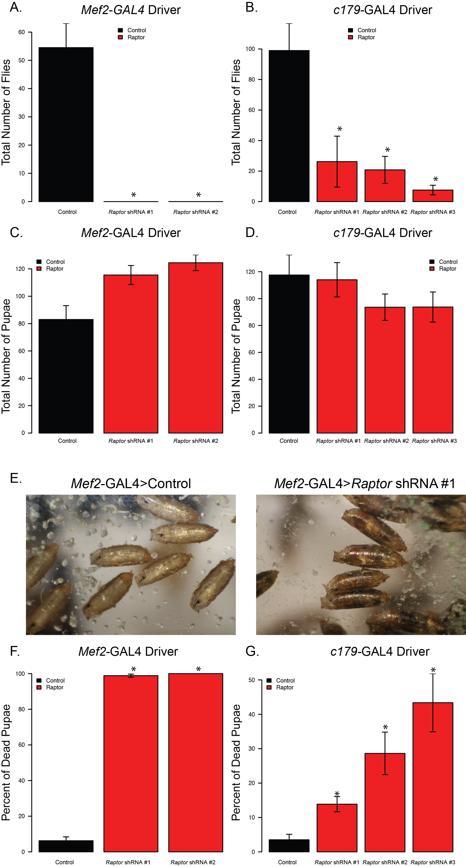

**Figure 3. Muscle-specific Raptor knockdown flies die around pupal stage ~12-13 but pre-eclosure.** The graph depicts the birthrates of the progeny from crosses of homozygous GAL4driver lines with homozygous *Raptor* shRNA transgenic flies or a control TRiP line. Panels A, C and F indicate *Mef2-*GAL4 driven knockdowns while B, D and G indicate *c179-*GAL4mediated knockdowns. A) and B) show the total number of flies eclosed; C) and D) indicate the total number of pupae after 20 days, and F) and G) show the percentage of dead pupae. Panel E) shows a representative example of dead flies, still within their pupal cases for *Mef2-*GAL4>UAS-*Raptor*-shRNA #1. Asterisks indicate p<0.05 by ANOVA followed by Dunnett’s test (B, C and D) or Kruskal-Wallis tests then Wilcoxon-rank-sum tests followed by an adjustment for multiple comparisons (A, F and G). Each of these analyses describe the average 5-9 independent crosses, with error bars indicating standard error of the mean between replicate crosses.

## Muscle *Raptor* Knockdown Flies Fail to Eclose from Pupae

To determine at which point prior to eclosure the *Raptor* knockdown flies die, we examined the pupal cases on the sides of the vials from the *cl79-*GAL4 *>* UAS-*Raptor*-shRNAcrosses and the *Mef2-*GAL4 *>* UAS-*Raptor-*shRNAcrosses. Twenty days after the crosses were prepared both the empty pupal cases and the cases containing dead flies were counted. We observed no significant differences in the total number of pupal cases from either of these crosses (Figure 3C-D, p=0.416 and p=0.066 from ANOVA respectively). In fact, we observed a slightly increased number of pupae from the *Mef2-*GAL4 > UAS-*Raptor*-shRNA crosses. These data support the hypothesis that lethality occurs after pupal development.

We next visually examined the pupal cases for the presence dead flies (Figure 3E). After blind scoring, we noted that for the *Mef2-*GAL4 driven *Raptor* knockdown nearly 100% of the pupal cases contained dead flies using two different anti-*Raptor* shRNA lines (15 fold more dead pupae than controls; Figure 3F). There was also a significant number of dead flies in pupal cases from the *cl79-*GAL4*>*UAS*-Raptor-*shRNAcrosses (Figure 3G). Although the absolute number of dead pupae was variable among the shRNA-*Raptor* lines using c179-GAL4, in all cases the percentage of dead flies in pupal cases was significantly greater than controls (Figure 3G). These results demonstrate that *Raptor* knockdown in skeletal muscle produces lethality after pupal development, but prior to eclosure.

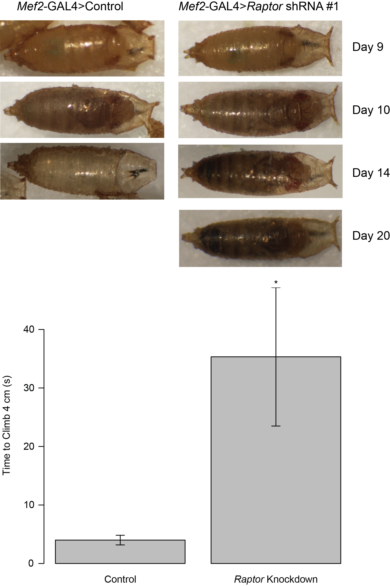

**Figure 4. *Mef2-*GAL4Driven *Raptor* Flies Cannot Eclose from Pupal Cases.** A)Flies with *Mef2-*GAL4driven knockdown of the control shRNA or *Raptor* shRNA #1 were examined from pupal stage 10 till after eclosure. By day 14 after the cross, control flies had completely eclosed but *Raptor* knockdown flies remained inside the pupal cases. B) On day 10, (approximately pupal stage 12) pupal cases were cut open at the operculum to assist eclosure, then after 4 days, climbing assays were performed on escaping flies. The flies that *Mef2-*GAL4*>Raptor* shRNA flies that eclosed with assistance had impaired climbing. Asterisk indicates p<0.005 by Wilcoxon Rank Sum test.

## Lethality of *Raptor* knockdown in skeletal muscle is due to an inability to eclose from the pupal case

To test whether the muscle *Raptor* knockdown-mediated lethality is due to a muscle weakness that prevents eclosure, we first carefully examined fly morphology within pupal cases. As shown in Figure 4A ten days after the cross a fully formed fly is visible within the pupal case and looks morphologically similar to control flies. By day 14 the control flies have completely eclosed leaving only empty pupal cases while the *Mef2-*GAL4>*Raptor* flies are still in the pupal case. By day 20 the flies have started to decompose and appear dark as in Figure 3E.

To determine if this is due to an inability of the fly to exit the pupal case, we gently opened 5 pupal cases by removal of the operculum at day 10 (approximately stage 12-13 pupae) from *Mef2-*GAL4>*Raptor* knockdown flies to assist in eclosure. In 4 out of 5 cases the flies eclosed successfully with 3 of these animals surviving >3 weeks. To validate that these eclosure-assisted flies had muscle weaknesses we performed climbing assays as shown in Figure 4B. The *Mef2-*GAL4>*Raptor* flies exhibited dramatically reduced climbing ability as compared to controls indicating muscle weakness (p=0.0025 by Wilcoxon Rank Sum Test).

## Effects of Muscle-Specific *Raptor* Knockdown on Longevity

We next turned our attention to the few flies that survived from the *c179-*GAL4 cross. The lifespan of these *Raptor* knockdown flies was measured to determine the effects of dTORC1suppression on longevity. When *Raptor* was knocked down in skeletal muscle using the *c179-*GAL4driver, a large proportion of the flies that successfully eclosed died shortly afterwards. Interestingly, among the flies that survived, they generally had normal lifespan (see Figure 5). This suggests that there is a critical period of about 20 days after eclosure during which the *Raptor* knockdown flies are still prone to early death. The flies that lived past this critical period lived on to reach approximately the same age as the controls. This was especially dramatic for male flies for each of these crosses (Figure 5A, C and E compared to Figure 5B, D and F).

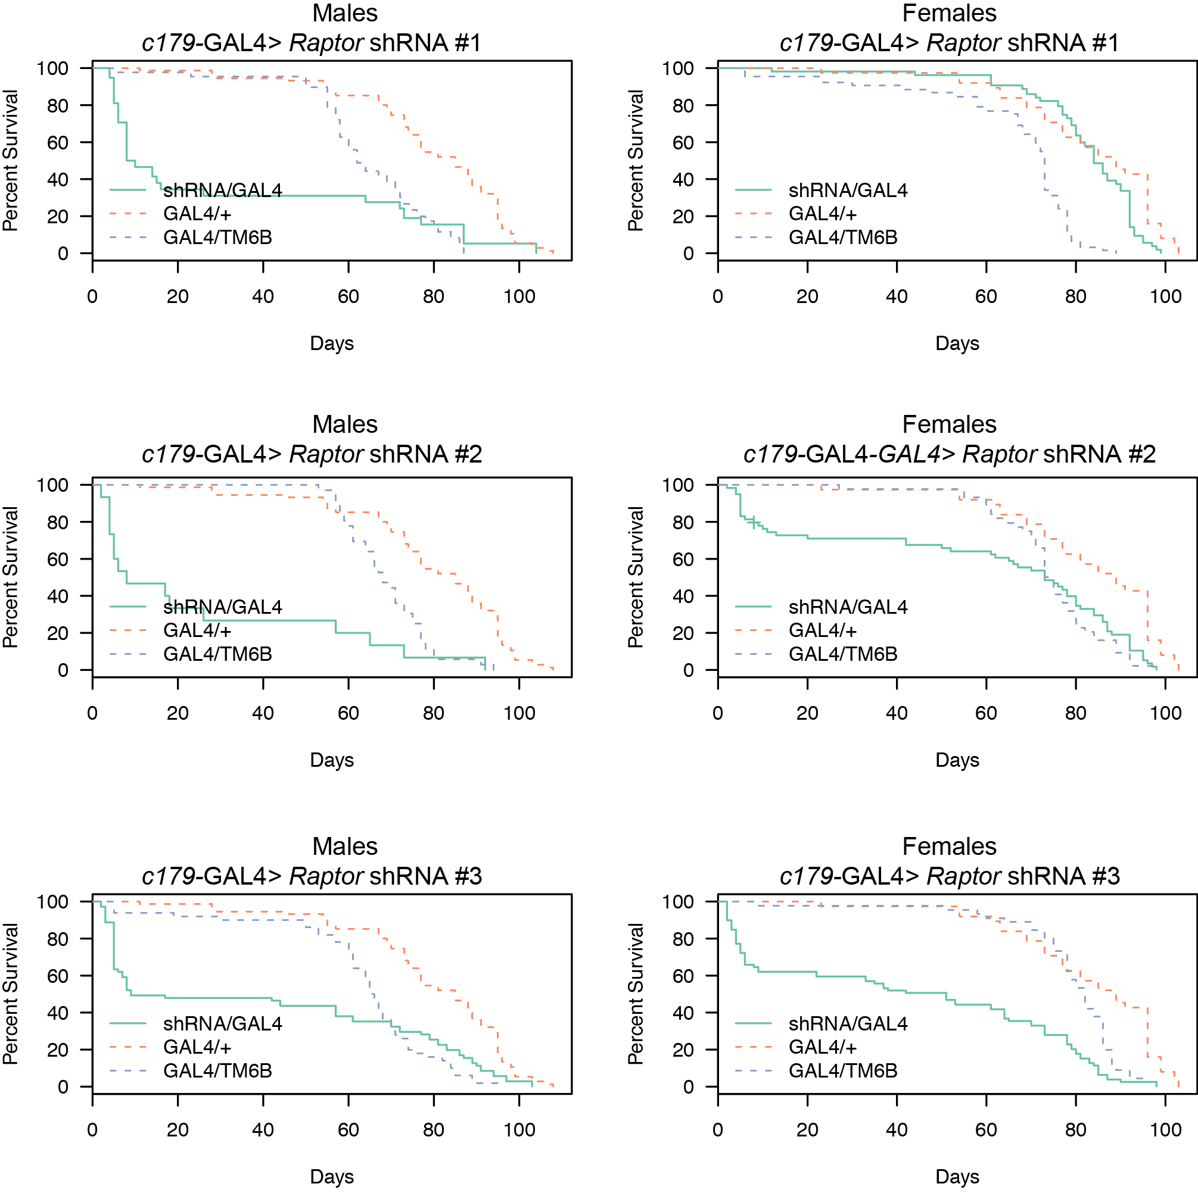

**Figure 5. Lifespan of *C179-*GAL4 Driven *Raptor* Knockdown Flies.** Dashed lines indicate two control strains. Each panel shows a control of *C179*-GAL4 crossed to the control shRNA strain, as well as the balancer containing progeny of the *C179*-GAL4 homozygotes crossed to the heterozygous UAS-*Raptor* shRNA/TM6b flies.

## Effects of Muscle Specific *Raptor* Knockdown on Muscle Function

To study the effects of dTORC1 suppression on muscle function, a climbing assay was performed on the *Raptor* knockdown flies driven by the *c179-*GAL4driver at several ages. Progeny from each cross were individually timed for how long it took them to climb 4 cm up the side of the vial. The average times for each cross are shown in Figure 6. The results indicate that dTORC1 suppression leads to reduced muscle function in the flies that eclose even very early, consistent a developmental problem in myogenesis. Notably, these problems persist throughout the lifespan of the fly, even in those animals that reach adulthood and have an average lifespan. Also interesting, is that there was a correspondence between the efficiency of the shRNA strain to cause lethality and its effects on climbing ability, indicating a potential gene-dosage effect on both of these phenotypes. This is consistent with other work in flies showing a correlation between climbing and lifespan37–40, indicating that muscle strength and aging are often linked, as is observed in humans41–43.

## Summary

In this work, we have described a role for TORC1 in the regulation of myogenesis both *in vitro* and *in vivo* in Drosophila, that inhibition of the dTORC1 complex results in lethality and muscle weakness. Together these data support an *in vivo*, evolutionarily conserved role for the TORC1 complex in muscle development.

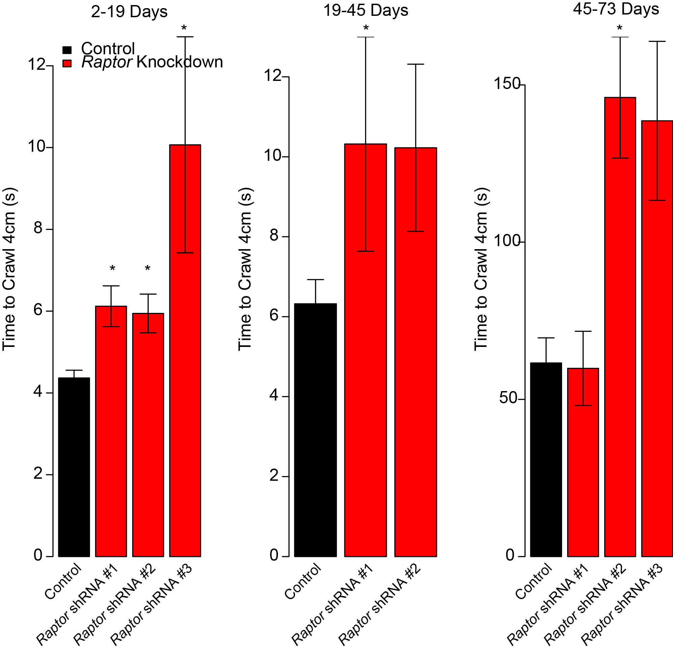

**Figure 6: Muscle-specific Raptor knockdown flies have reduced climbing rate.** Average climbing rate as measured during three age range intervals (in days) for *c179-*GAL4 driven *Raptor* knockdown flies. Asterisk indicates p<0.05 based on a Wilcoxon Rank-Sum test relative to the control flies, and adjusted for multiple observations. Note that the different abscissa indicates age-related slowing of climbing speed.

## Acknowledgements

The authors would like to thank the members of the Bridges and Reiter labs for insightful discussions and C. Valdez for animal husbandry. This work was supported in part by a Dean’s Neurology Support Fund to LTR.

## Author Contributions

Dave Bridges (DB), Innocence Harvey and Lawrence T. Reiter (LTR) prepared the manuscript. Innocence Harvey performed the experiments in Figure 1 and analyzed the data. Isabelle Hatfield performed the experiments in Figures 2, 3, 5 and 6 while DB analyzed the data. LTR performed and analyzed the experiment in Figure 4A, DB performed and analyzed the experiment in Figure 4B. DB prepared the figures. DB and Innocence Harvey designed the experiments and interpreted the results in Figure 1. DB, LTR and Isabelle Hatfield designed and interpreted the results in Figures 2-6. All authors reviewed the manuscript.

## References

1. Loewith, R. & Hall, M. N. Target of rapamycin (TOR) in nutrient signaling and growth control. *Genetics* **189,** 1177–201 (2011).

2. Zoncu, R., Efeyan, A. & Sabatini, D. M. mTOR: from growth signal integration to cancer, diabetes and ageing. *Nat. Rev. Mol. Cell Biol.* **12,** 21–35 (2010).

3. Howell, J. J., Ricoult, S. J. H., Ben-Sahra, I. & Manning, B. D. A growing role for mTOR in promoting anabolic metabolism. *Biochem. Soc. Trans.* **41,** 906–12 (2013).

4. Cornu, M., Albert, V. & Hall, M. N. mTOR in aging, metabolism, and cancer. *Curr. Opin. Genet. Dev.* **23,** 53–62 (2013).

5. Lamming, D. W., Ye, L., Sabatini, D. M. & Baur, J. A. Rapalogs and mTOR inhibitors as anti-aging therapeutics. *J. Clin. Invest.* **123,** 980–9 (2013).

6. Zeng, M. & Zhou, J.-N. Roles of autophagy and mTOR signaling in neuronal differentiation of mouse neuroblastoma cells. *Cell. Signal.* **20,** 659–65 (2008).

7. Tyler, W. A. *et al.* Activation of the mammalian target of rapamycin (mTOR) is essential for oligodendrocyte differentiation. *J. Neurosci.* **29,** 6367–78 (2009).

8. Zhang, H. H. *et al.* Insulin stimulates adipogenesis through the Akt-TSC2-mTORC1 pathway. *PLoS One* **4,** e6189 (2009).

9. Cuenda, a & Cohen, P. Stress-activated protein kinase-2/p38 and a rapamycin-sensitive pathway are required for C2C12 myogenesis. *J. Biol. Chem.* **274,** 4341–6 (1999).

10. Shu, L., Zhang, X. & Houghton, P. J. Myogenic differentiation is dependent on both the kinase function and the N-terminal sequence of mammalian target of rapamycin. *J. Biol. Chem.* **277,** 16726–32 (2002).

11. Erbay, E. & Chen, J. The mammalian target of rapamycin regulates C2C12 myogenesis via a kinase-independent mechanism. *J. Biol. Chem.* **276,** 36079–82 (2001).

12. Hentges, K. E. *et al.* FRAP/mTOR is required for proliferation and patterning during embryonic development in the mouse. *Proc. Natl. Acad. Sci. U. S. A.* **98,** 13796–801 (2001).

13. Guertin, D. A. *et al.* Ablation in mice of the mTORC components raptor, rictor, or mLST8 reveals that mTORC2 is required for signaling to Akt-FOXO and PKCalpha, but not S6K1. *Dev. Cell* **11,** 859–871 (2006).

14. Gangloff, Y. *et al.* Disruption of the mouse mTOR gene leads to early postimplantation lethality and prohibits embryonic stem cell development. *Mol. Cell. Biol.* **24,** 9508–16 (2004).

15. Jia, K., Chen, D. & Riddle, D. L. The TOR pathway interacts with the insulin signaling pathway to regulate C. elegans larval development, metabolism and life span. *Development* **131,** 3897–906 (2004).

16. Bjedov, I. *et al.* Mechanisms of life span extension by rapamycin in the fruit fly Drosophila melanogaster. *Cell Metab.* **11,** 35–46 (2010).

17. Mauro, A. Satellite cell of skeletal muscle fibers. *J. Biophys. Biochem. Cytol.* **9,** 493–5 (1961).

18. Collins, C. a *et al.* Stem cell function, self-renewal, and behavioral heterogeneity of cells from the adult muscle satellite cell niche. *Cell* **122,** 289–301 (2005).

19. McCarthy, J. J. *et al.* Effective fiber hypertrophy in satellite cell-depleted skeletal muscle. *Development* **138,** 3657–66 (2011).

20. Eng, D., Ma, H.-Y., Gross, M. K. & Kioussi, C. Gene Networks during Skeletal Myogenesis. *ISRN Dev. Biol.* **2013,** 1–8 (2013).

21. Ge, Y. & Chen, J. Mammalian target of rapamycin (mTOR) signaling network in skeletal myogenesis. *J. Biol. Chem.* (2012). doi:10.1074/jbc.R112.406942

22. Sun, Y. *et al.* Mammalian target of rapamycin regulates miRNA-1 and follistatin in skeletal myogenesis. *J. Cell Biol.* **189,** 1157–69 (2010).

23. Yaffe, D. & Saxel, O. Serial passaging and differentiation of myogenic cells isolated from dystrophic mouse muscle. *Nature* **270,** 725–727 (1977).

24. Schmittgen, T. D. & Livak, K. J. Analyzing real-time PCR data by the comparative CT method. *Nat. Protoc.* **3,** 1101–1108 (2008).

25. Ni, J. *et al.* A genome-scale shRNA resource for transgenic RNAi in Drosophila. *Nat. Methods* **8,** 405–7 (2011).

26. R Core Team. R: A Language and Environment for Statistical Computing. (2013).

27. Fox, J. & Weisberg, S. *An {R} Companion to Applied Regression*. (Sage, 2011).

28. Benjamini, Y. & Hochberg, Y. Controlling the False Discovery Rate: A Practical and Powerful Approach to Multiple Testing. *J. R. Stat. Soc. Ser. B* **57,** 289–300 (1995).

29. Hatfield, I., Harvey, I., Reiter, L. T. & Bridges, D. Dataset for Drosophila Muscle Function Studies. (2014). at <http://bridgeslab.github.io/DrosophilaMuscleFunction/>

30. Berkes, C. a & Tapscott, S. J. MyoD and the transcriptional control of myogenesis. *Semin. Cell Dev. Biol.* **16,** 585–95 (2005).

31. Rogerson, P. J., Jamali, M. & Skerjanc, I. S. The C-terminus of myogenin, but not MyoD, targets upregulation of MEF2C expression. *FEBS Lett.* **524,** 134–8 (2002).

32. Murakami, M. *et al.* mTOR is essential for growth and proliferation in early mouse embryos and embryonic stem cells. *Mol. Cell. Biol.* **24,** 6710–8 (2004).

33. Duffy, J. B. GAL4 system in Drosophila: a fly geneticist’s Swiss army knife. *Genesis* **34,** 1–15 (2002).

34. Mantrova, E. Y., Schulz, R. a. & Hsu, T. Oogenic function of the myogenic factor D-MEF2: Negative regulation of the Decapentaplegic receptor gene thick veins. *Proc. Natl. Acad. Sci.* **96,** 11889–11894 (1999).

35. Bentzinger, C. F. *et al.* Skeletal muscle-specific ablation of raptor, but not of rictor, causes metabolic changes and results in muscle dystrophy. *Cell Metab.* **8,** 411–24 (2008).

36. Bentzinger, C. F. *et al.* Differential response of skeletal muscles to mTORC1 signaling during atrophy and hypertrophy. *Skelet. Muscle* **3,** 6 (2013).

37. Leffelaar, D. & Grigliatti, T. A. A Mutation in Drosophila That Appears to Accelerate Aging. **210,** 199–210 (1984).

38. Demontis, F., Patel, V. K., Swindell, W. R. & Perrimon, N. Intertissue Control of the Nucleolus via a Myokine-Dependent Longevity Pathway. *Cell Rep.* 1–14 (2014). doi:10.1016/j.celrep.2014.05.001

39. Demontis, F. & Perrimon, N. FOXO/4E-BP signaling in Drosophila muscles regulates organism-wide proteostasis during aging. *Cell* **143,** 813–25 (2010).

40. Muffat, J. *et al.* Hypersensitivity to oxygen and shortened lifespan in a Drosophila mitochondrial complex II mutant. (2006).

41. Pia, L., Heikkinen, E. & Kauppinen, M. Muscle Strength and Mobility as Predictors of Survival in 75–84 - Year - old People. *Age Ageing* **24,** 468–473 (1995).

42. Ruiz, J. R. *et al.* Association between muscular strength and mortality in men: prospective cohort study. *BMJ* **337,** a439 (2008).

43. Cooper, R., Kuh, D. & Hardy, R. Objectively measured physical capability levels and mortality: systematic review and meta-analysis. *BMJ* **341,** c4467 (2010).